BIG DATA ANALYTICS PROJECT
REVIEW 1

TEAM MEMBERS:
1. Nandini Goyal 23BIT0419
2. Netal Agarwal 23BIT0161
3. Khushi Kumari 23BIT0069

TITLE:

Judicial Outcome Prediction and Bias-Aware Analysis Using Hierarchical Semantic Vector Clustering in Apache Spark

ABSTRACT:

Judicial systems worldwide face increasing pressure due to growing case backlogs and the need for consistent, well-reasoned decisions. This project presents an intelligent judicial assistance system designed to support legal decision making through transparent and accountable analysis.

The system predicts probable case outcomes while generating structured, judge readable reasoning aligned with relevant statutory provisions and judicial precedents.

To address concerns of fairness, it also identifies and quantifies historical bias present in past judicial decisions based on non-legal factors, presenting both unadjusted and bias-aware recommendations.

By explicitly separating predictive outcomes from explanatory reasoning and bias indicators, the proposed approach avoids black-box behavior and preserves judicial discretion. The system aims to enhance efficiency, transparency, and trust in technology-assisted judicial processes while supporting fair and informed decision-making.

LITERATURE SURVEY
S.NO | PAPER TITLE | PROPOSAL | PROS | CONS | RESEARCH GAP
1 | Legal Judgment Prediction using Natural Language Processing (2025) | Proposes an NLP-based framework to predict court verdicts using past judgments. | Improves prediction accuracy; uses real legal data. | Lacks explainability of predictions. | Does not explain why a verdict is predicted, reducing judicial trust.
2 | A Study of Legal Judgment Prediction Based on Deep Learning (2024) | Uses deep neural networks to classify legal outcomes. | High performance on benchmark datasets. | Acts as a black-box model. | No reasoning or legal justification provided with predictions.
3 | Legal Judgment Prediction Ensemble Model (2025) | Combines multiple ML models for better verdict prediction. | Reduces individual model bias; higher accuracy. | Computationally expensive. | Does not address bias present in historical data.
4 | NyayaRAG: Legal Judgment Prediction under Indian Common Law (2025) | Integrates retrieval-augmented generation for Indian legal cases. | Jurisdiction-specific; better legal relevance. | Limited explainability for final output. | Lacks structured legal reasoning aligned with statutes.
5 | Argumentation-Based Explainability for Legal AI (2025) | Introduces argumentation frameworks for legal AI explanations. | Improves interpretability. | Complex to implement at scale. | Does not integrate bias-aware corrections.
6 | Explainable AI and Law: An Evidential Survey (2024) | Surveys explainability techniques used in legal AI. | Strong theoretical foundation. | Mostly conceptual, not system-based. | No implementation framework combining explainability and prediction.
7 | Bridging Text and Knowledge: Explainable AI for Knowledge Graphs (2025) | Combines knowledge graphs with explainable AI. | Transparent reasoning paths. | Limited legal domain focus. | Does not apply judicial or precedent hierarchy.
8 | NyayGraph: Knowledge Graph Enhanced Statute Identification (2025) | Uses legal knowledge graphs for statute detection. | Improves statute relevance. | Focuses only on statute identification. | No verdict prediction or bias handling.
9 | Role of Knowledge Graphs in Explainable AI (2025) | Explains how KGs enhance explainability. | Strong interpretability support. | Generic AI focus. | Does not address legal accountability requirements.
10 | Improving Legal Question Answering using Structured Knowledge Graphs (2025) | Proposes KG-based legal QA systems. | Accurate answers; structured data. | Limited to QA tasks. | Not applied to judicial decision prediction.
11 | Natural Language Processing for the Legal Domain (2025) | Comprehensive survey of legal NLP techniques. | Covers datasets, models, challenges. | Broad overview, no specialization. | Does not propose explainable judicial systems.
12 | ReGal: Reinforcement Learning for Legal Reasoning (2025) | Uses RL to simulate legal reasoning. | Innovative learning approach. | Hard to interpret decisions. | No bias-awareness or explainability layer.
13 | HalluGraph: Auditable Hallucination Detection for Legal RAG (2025) | Detects hallucinations in legal AI outputs. | Improves reliability. | Focused on text generation. | Does not address verdict prediction or bias
14 | Assessing Trustworthy AI: Technical and Legal Perspectives (2024) | Examines fairness and trust in AI systems. | Strong ethical grounding. | Lacks technical implementation. | No concrete bias-correction mechanism.
15 | JustEva: Evaluating Fairness in Legal Knowledge Inference (2025) | Proposes fairness evaluation metrics for legal AI. | Quantifies bias clearly. | Only evaluation-based. | Does not correct bias in predictions.
16 | Public Perception of Judges Using AI Tools (2025) | Studies trust in AI-assisted judicial decisions. | Highlights importance of transparency. | Qualitative study only. | No technical solution proposed.
17 | Automating Court Judgment Prediction and Explanation (2026) | Combines prediction with textual explanations. | Integrates explanation with output. | Explanations are shallow. | Lacks structured legal reasoning aligned to statutes.
18 | Recent Trends in Legal AI: A Comprehensive Review (2025) | Reviews AI methods in legal systems. | Identifies open challenges. | High-level overview. | Does not propose bias-aware explainable systems.
19 | LegalViz: Visualization Techniques for Legal Reasoning (2025) | Introduces visualization of legal reasoning paths. | Improves interpretability. | Requires structured inputs. | No predictive or bias-aware functionality.
20 | From Case Law to Code: Evaluating AI’s Role in Justice (2024) | Discusses legal and ethical impact of AI. | Strong policy insights. | Non-technical. | No system-level implementation.
21 | Artificial Intelligence and Justice: A Systematic Review (2025) | Reviews AI usage in judicial systems. | Comprehensive coverage. | Does not propose new methods. | Lacks integrated explainability-bias solutions.
22 | Bias in Legal Decision Prediction Models (2024) | Analyzes bias in historical legal datasets. | Highlights critical fairness issues. | Only diagnostic. | No bias-adjusted prediction mechanism.
23 | Explainable Judicial Decision Support Systems (2025) | Proposes explainable legal DSS. | Improves transparency. | Limited to rule-based systems. | Does not scale with big data.
24 | Knowledge-Guided Legal Outcome Prediction (2026) | Uses legal knowledge to guide predictions. | Better legal consistency. | Ignores social bias factors. | No bias correction layer.

SYSTEM ARCHITECTURE:
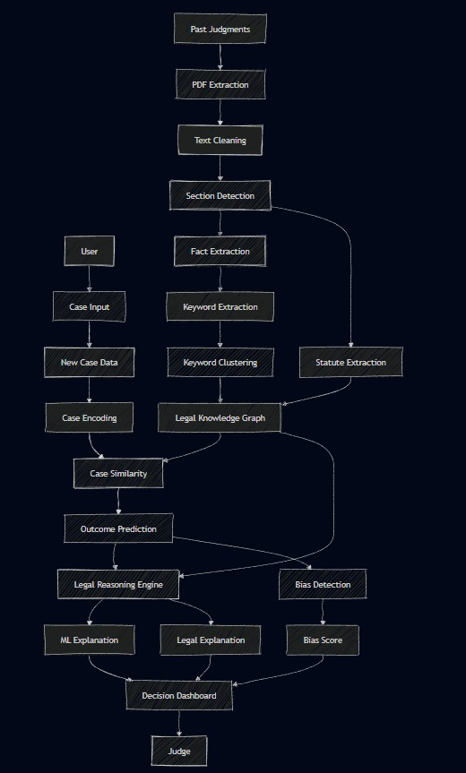

SOFTWARE REQUREMENT:

Use case | Software
PDF Ingestion | Apache Tika
Big data processing | Apache Spark
Storage | HDFS
Legal NLP | spaCy + InLegalBERT
Knowledge Graph | Neo4j
Similarity Search | Sentence Transformers + FAISS
Prediction | XGBoost
Explainability | Graph Traversal
Legal Mapping | Template based NLG
Bias detection | AIF360 + Fairlearn

ALGORITHMS USED:
S. No. | System Stage | Algorithm / Technique Used | Input to Algorithm | Output | Used in Next Stage
1 | PDF Text Extraction | PDF Parsing + OCR (if needed) | Court judgment PDF | Raw text | Text Cleaning
2 | Text Cleaning & Normalization | Tokenization, Stopword Removal, Lemmatization | Raw text | Clean normalized text | Section Identification
3 | Legal Section Identification | Rule-based Pattern Matching | Clean text | Structured sections (Facts, Issues, Statutes, Decision) | Keyword Extraction
4 | Keyword / Term Extraction | Noun Phrase Extraction, NER | Legal sections | Candidate legal terms | Term Scoring
5 | Term Importance Scoring | TF-IDF + Section-based Weighting | Candidate terms | Important legal terms | Keyword Clustering
6 | Keyword Clustering | Embedding-based Clustering (K-Means / Hierarchical) | Important terms (embeddings) | Legal concept clusters | Case Representation
7 | Text Representation | Transformer-based Embeddings (Legal-BERT / InLegalBERT) | Legal text / terms | Semantic vectors | Clustering, Similarity
8 | Case Representation | Feature Aggregation | Clusters + statutes + metadata | Case feature vector | Similarity Matching
9 | Case Similarity Matching | Cosine Similarity + KNN | New case vector + past case vectors | Top-K similar cases | Prediction, Reasoning
10 | Outcome Prediction | XGBoost / Logistic Regression | Features from similar cases | Probable verdict + confidence | Explanation, Bias
11 | Knowledge Graph Traversal | Graph Traversal Algorithms | Case, statute, concept nodes | Relevant statutes & precedents | Legal Reasoning
12 | Structured Legal Reasoning | Rule-based Reasoning | Statutes + precedents | Reasoning trail | Judge Explanation
13 | Judge-Readable Explanation | Template-based NLG + Mapping Rules | Scores + reasoning | Plain legal explanation | Final Output
14 | Bias Detection | Statistical Disparity Analysis | Verdicts + non-legal attributes | Bias score + confidence | Final Output
15 | Final Decision Support | Presentation Logic | Prediction + reasoning + bias | Decision-support output | End User

PROBLEM STATEMENT IDENTIFICATION:
Judicial systems across many jurisdictions are burdened by increasing case backlogs, leading to delays in decision-making and inconsistent legal outcomes. Judges and legal practitioners must examine large volumes of past case records to identify relevant precedents and applicable statutory provisions, a process that is time-consuming and cognitively demanding. While existing legal decision-support tools focus on predicting case outcomes, many operate as black-box systems, offering little transparency into the reasoning behind their recommendations. This lack of explainability reduces judicial trust and limits practical adoption. Additionally, historical judicial data may contain hidden biases related to non-legal factors such as region or socio-economic background, which can unintentionally influence predictive systems if left unaddressed. Therefore, there is a need for a judicial assistance system that not only supports outcome prediction but also provides structured, judge-readable legal reasoning and explicitly identifies potential historical bias, ensuring transparency, fairness, and informed judicial discretion.
EXPECTED OUTCOME:

The expected outcome of this project is the development of a transparent and accountable judicial assistance system that supports legal decision-making without replacing judicial authority. The system is expected to provide probable case outcomes along with structured, judge-readable legal reasoning aligned with relevant statutes and judicial precedents. By explicitly presenting the reasoning process, the system aims to enhance judicial trust and reduce reliance on opaque, black-box recommendations. Additionally, the project is expected to identify and quantify historical bias present in past judicial decisions based on non-legal factors, enabling greater awareness of fairness concerns. The dual presentation of unadjusted and bias-aware recommendations is expected to support informed judicial discretion rather than automated decision-making. Overall, the project is anticipated to contribute to improved efficiency, consistency, transparency, and fairness in technology-assisted judicial processes.

